Date: 14th Dec, 2018

**Timesheet Management System**

**1. User-**

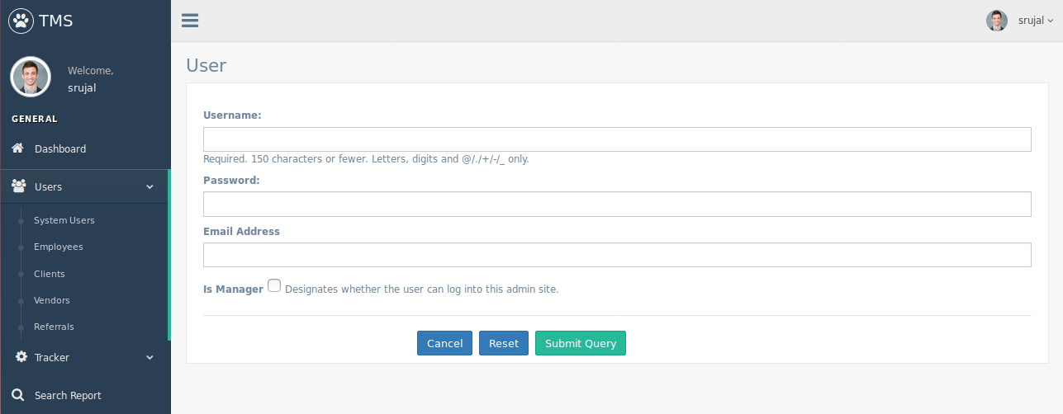

**What:**

This page will capture a user information.

**Who:**

Admin user of Triveni will use this page.

**When:**

2 days.

**Description:**

In Timesheet Management System, follow below steps-

* Login into admin account.
* Go to ‘Users’ menu and then select submenu ‘System Users’.
* Admin will get a list of users.
* Admin can perform add/edit/delete operation by clicking on create/edit/delete button respectively.

**Use Case:**

* Add new user-
* Admin save a user information like username, password, email and is_manager.
* Admin User can perform one of the following action on this page-
  + ‘Cancel’ button should redirect user to list page.
  + ‘Submit Query’ should save details on the form.
  + ‘Reset’ should reset data in the form.
* Edit existing user-
* Initially, admin should get all saved information of this user in the form.
* User should update and save a client information like email and is_staff only.
* Admin User can perform one of the following action on this page-
  + ‘Cancel’ button should redirect user to list page.
  + ‘Submit Query’ should save details on the form.
  + ‘Reset’ should reset data in the form.
* Delete existing client-
* Admin should get confirmation message and do one of the following action on this page-
  + ‘Cancel’ button should redirect user to list page.
  + ‘Submit’ should delete this user.

**Inputs/Defaults:**

Add or Update data in the form of a user entity.

**Outputs:**

Added new user or Updated existing user information or delete user.

**2. Client-**

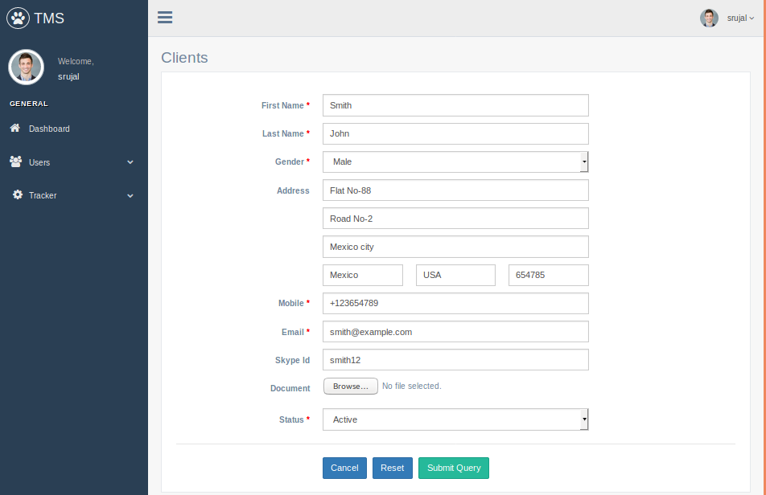

**What:**

This page will capture a client information.

**Who:**

Admin user of Triveni will use this page.

**When:**

4 days.

**Description:**

In Timesheet Management System, follow below steps-

* Login into admin account.
* Go to ‘Users’ menu and then select submenu ‘Clients’.
* Admin will get a list of clients.
* Admin can perform add/edit/delete operation by clicking on create/edit/delete button respectively.

**Use Case:**

* Add new client-
* User save a client information like name, gender, address, contact information and status. Admin can also upload any document or image related this client entity.
* Admin User can perform one of the following action on this page-
  + ‘Cancel’ button should redirect user to list page.
  + ‘Submit Query’ should save details on the form.
  + ‘Reset’ should reset data in the form.
* Edit existing client-
* Initially, user should get all saved information of this client in the form.
* User should update and save a client information like name, gender, address, contact information and status. Admin can also upload any new document or image related this client entity.
* Admin User can perform one of the following action on this page-
  + ‘Cancel’ button should redirect user to list page.
  + ‘Submit Query’ should save details on the form.
  + ‘Reset’ should reset data in the form.
* Delete existing client-
* User should get confirmation message and do one of the following action on this page-
  + ‘Cancel’ button should redirect user to list page.
  + ‘Submit’ should delete this client.

**Inputs/Defaults:**

Add or Update data in the form of a client entity.

**Outputs:**

Added new client or Updated existing client information or delete client.

**3. Employee-**

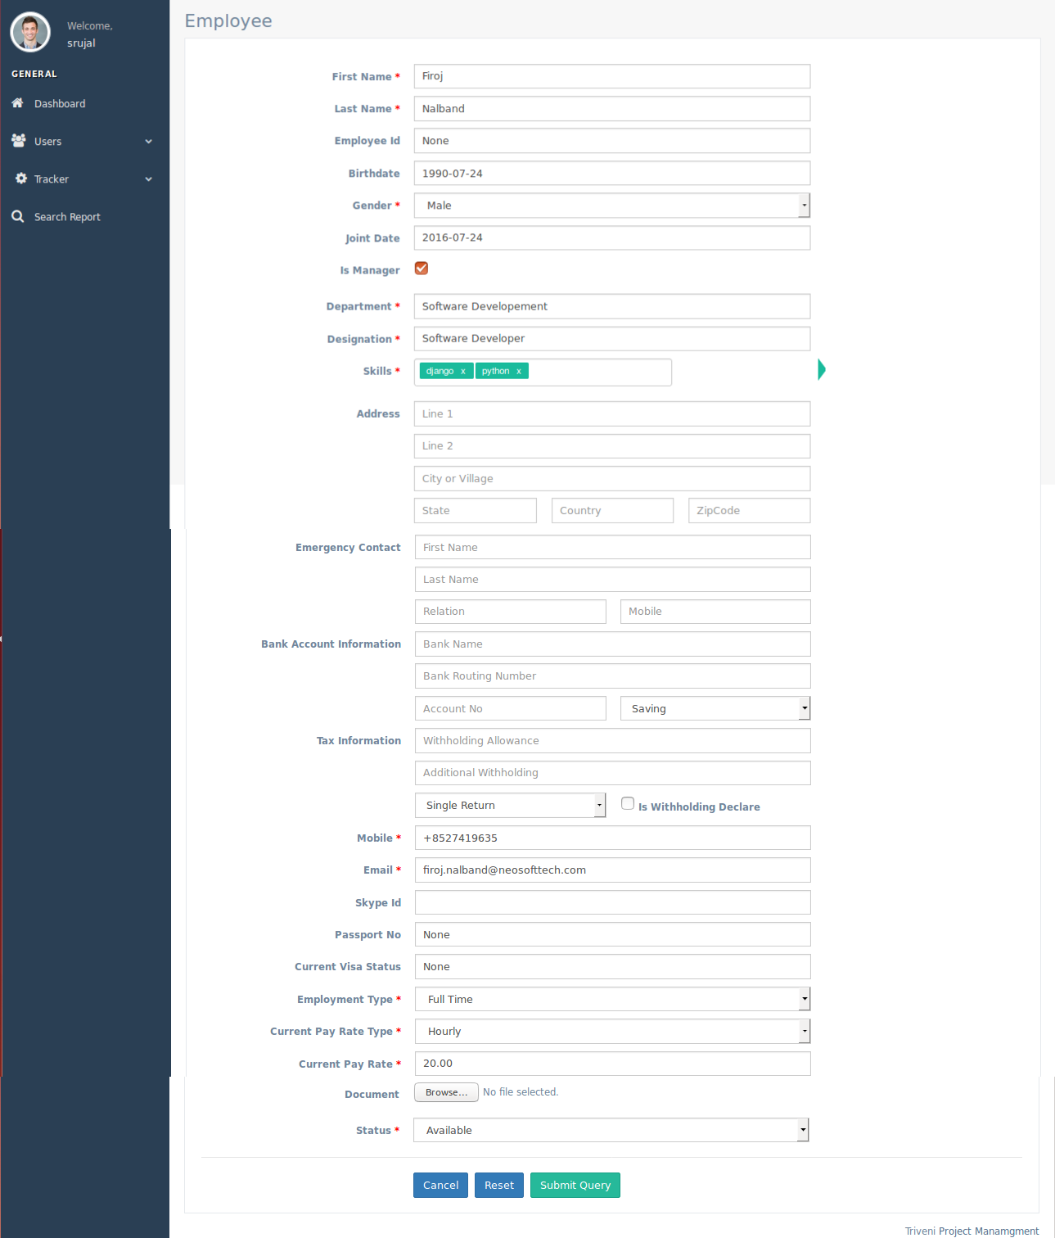

**What:**

This page will capture an employee information.

**Who:**

Admin user of Triveni will use this page.

**When:**

5 days.

**Description:**

In Timesheet Management System, follow below steps-

* Login into admin account.
* Go to ‘Users’ menu and then select submenu ‘Employees’.
* Admin will get a list of employees.
* Admin can perform add/edit/delete operation by clicking on create/edit/delete button respectively.

**Use Case:**

* Add new employee-
* User save an employee information like name, gender, address, contact information, employment information, bank information, tax information and status. Admin can also upload any document or image related this employee entity.
* Admin User can perform one of the following action on this page-
  + ‘Cancel’ button should redirect user to list page.
  + ‘Submit Query’ should save details on the form.
  + ‘Reset’ should reset data in the form.
* Edit existing employee-
* Initially, user should get all saved information of this employee in the form.
* User should update and save an employee information like name, gender, address, contact information and status. Admin can also upload any new document or image related this employee entity.
* Admin User can perform one of the following action on this page-
  + ‘Cancel’ button should redirect user to list page.
  + ‘Submit Query’ should save details on the form.
  + ‘Reset’ should reset data in the form.
* Delete existing employee-
* User should get confirmation message and do one of the following action on this page-
  + ‘Cancel’ button should redirect user to list page.
  + ‘Submit’ should delete this employee.

**Inputs/Defaults:**

Add or Update data in the form of an employee entity.

**Outputs:**

Added new employee or Updated existing employee information or delete employee.

**4. Vendor-**

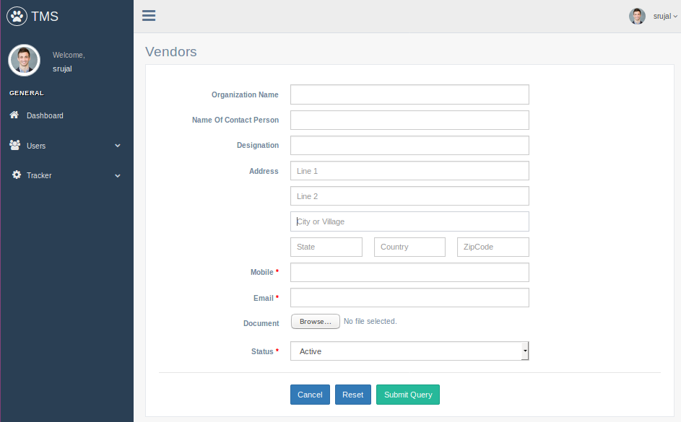

**What:**

This page will capture a vendor information.

**Who:**

Admin user of Triveni will use this page.

**When:**

3 days.

**Description:**

In Timesheet Management System, follow below steps-

* Login into admin account.
* Go to ‘Users’ menu and then select submenu ‘Vendors’.
* Admin will get a list of vendors.
* Admin can perform add/edit/delete operation by clicking on create/edit/delete button respectively.

**Use Case:**

* Add new vendor-
* User save a vendor information like organization_name, details of contact person and status. Admin can also upload any document or image related this vendor entity.
* Admin User can perform one of the following action on this page-
  + ‘Cancel’ button should redirect user to list page.
  + ‘Submit Query’ should save details on the form.
  + ‘Reset’ should reset data in the form.
* Edit existing vendor-
* Initially, user should get all saved information of this vendor in the form.
* User should update and save a vendor information like organization_name, details of contact person and status. Admin can also upload any new document or image related this vendor entity.
* Admin User can perform one of the following action on this page-
  + ‘Cancel’ button should redirect user to list page.
  + ‘Submit Query’ should save details on the form.
  + ‘Reset’ should reset data in the form.
* Delete existing vendor-
* User should get confirmation message and do one of the following action on this page-
  + ‘Cancel’ button should redirect user to list page.
  + ‘Submit’ should delete this vendor.

**Inputs/Defaults:**

Add or Update data in the form of a vendor entity.

**Outputs:**

Added new vendor or Updated existing vendor information or delete vendor.

**5. Referral-**

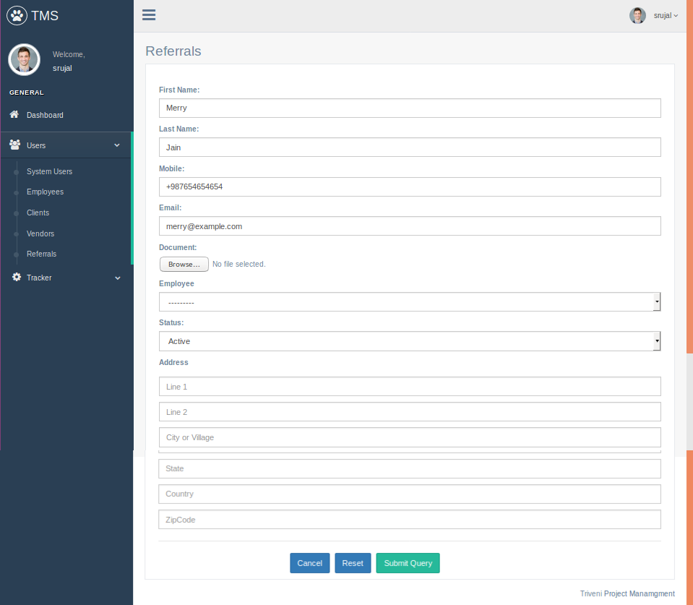

**What:**

This page will capture a referral information.

**Who:**

Admin user of Triveni will use this page.

**When:**

4 days.

**Description:**

In Timesheet Management System, follow below steps-

* Login into admin account.
* Go to ‘Users’ menu and then select submenu ‘Referrals’.
* Admin will get a list of referrals.
* Admin can perform add/edit/delete operation by clicking on create/edit/delete button respectively.

**Use Case:**

* Add new referral-
* User save a referral information like name, gender, address, contact information and status. Admin can also upload any document or image related this referral entity. Referral may be employee or external person.
* Admin User can perform one of the following action on this page-
  + ‘Cancel’ button should redirect user to list page.
  + ‘Submit Query’ should save details on the form.
  + ‘Reset’ should reset data in the form.
* Edit existing vendor-
* Initially, user should get all saved information of this referral in the form.
* User should update and save a referral information like name, gender, address, contact information and status. Admin can also upload any new document or image related this referral entity.
* Admin User can perform one of the following action on this page-
  + ‘Cancel’ button should redirect user to list page.
  + ‘Submit Query’ should save details on the form.
  + ‘Reset’ should reset data in the form.
* Delete existing vendor-
* User should get confirmation message and do one of the following action on this page-
  + ‘Cancel’ button should redirect user to list page.
  + ‘Submit’ should delete this referral.

**Inputs/Defaults:**

Add or Update data in the form of a referral entity.

**Outputs:**

Added new referral or Updated existing referral information or delete referral.

**6. Project-**

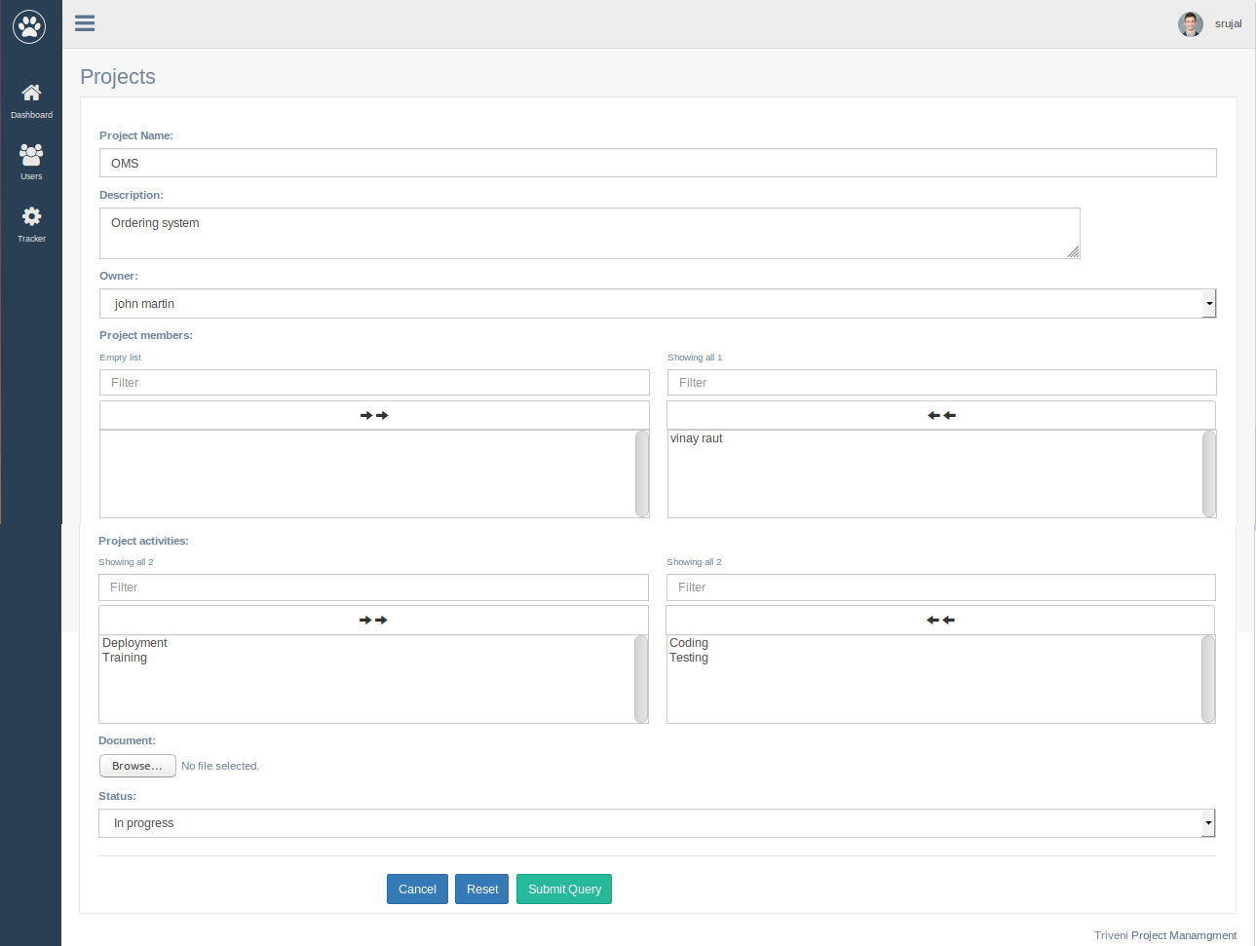

**What:**

This page will capture a project information.

**Who:**

Admin user of Triveni will use this page.

**When:**

4 days.

**Description:**

In Timesheet Management System, follow below steps-

* Login into admin account.
* Go to ‘Tracker’ menu and then select submenu ‘Projects’.
* Admin will get a list of projects.
* Admin can perform add/edit/delete operation by clicking on create/edit/delete button respectively.

**Use Case:**

* Add new project-
* User save a project information like name, description, owner, members, activities and status. Admin can also upload any document or image related this project.
* Admin User can perform one of the following action on this page-
  + ‘Cancel’ button should redirect user to list page.
  + ‘Submit Query’ should save details on the form.
  + ‘Reset’ should reset data in the form.
* Edit existing project-
* Initially, user should get all saved information of this project in the form.
* User should update and save a project information like name, description, owner, members, activities and status. Admin can also upload any new document or image related this project.
* Admin User can perform one of the following action on this page-
  + ‘Cancel’ button should redirect user to list page.
  + ‘Submit Query’ should save details on the form.
  + ‘Reset’ should reset data in the form.
* Delete existing project-
* User should get confirmation message and do one of the following action on this page-
  + ‘Cancel’ button should redirect user to list page.
  + ‘Submit’ should delete this project.

**Inputs/Defaults:**

Add or Update data in the form of a project entity.

**Outputs:**

Added new project or Updated existing project information or delete project.

**7. Contract-**

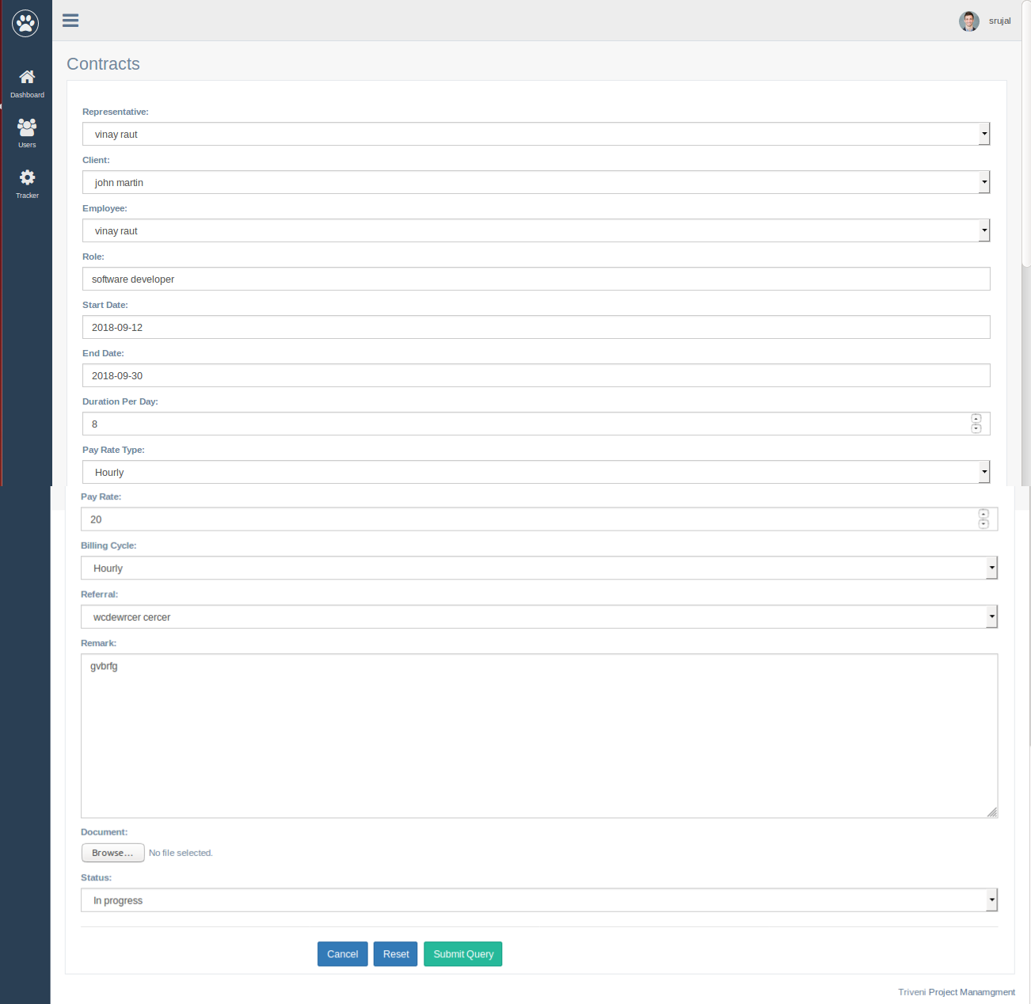

**What:**

This page will capture a contract information.

**Who:**

Admin user of Triveni will use this page.

**When:**

4 days.

**Description:**

In Timesheet Management System, follow below steps-

* Login into admin account.
* Go to ‘Tracker’ menu and then select submenu ‘Contracts’.
* Admin will get a list of contracts.
* Admin can perform add/edit/delete operation by clicking on create/edit/delete button respectively.

**Use Case:**

* Add new contract-
* User save a contract information like representative, client, employee, role, start date, end date, referral, payment information, billing cycle and status. Admin can also upload any document or image related this contract.
* Admin User can perform one of the following action on this page-
  + ‘Cancel’ button should redirect user to list page.
  + ‘Submit Query’ should save details on the form.
  + ‘Reset’ should reset data in the form.
* Edit existing contract-
* Initially, user should get all saved information of this contract in the form.
* User should update and save a contract information like representative, client, employee, role, start date, end date, referral, payment information, billing cycle and status. Admin can also upload any new document or image related this contract.
* Admin User can perform one of the following action on this page-
  + ‘Cancel’ button should redirect user to list page.
  + ‘Submit Query’ should save details on the form.
  + ‘Reset’ should reset data in the form.
* Delete existing contract-
* User should get confirmation message and do one of the following action on this page-
  + ‘Cancel’ button should redirect user to list page.
  + ‘Submit’ should delete this contract.

**Inputs/Defaults:**

Add or Update data in the form of a contract entity.

**Outputs:**

Added new contract or Updated existing contract information or delete contract.

**8. Timesheet-**

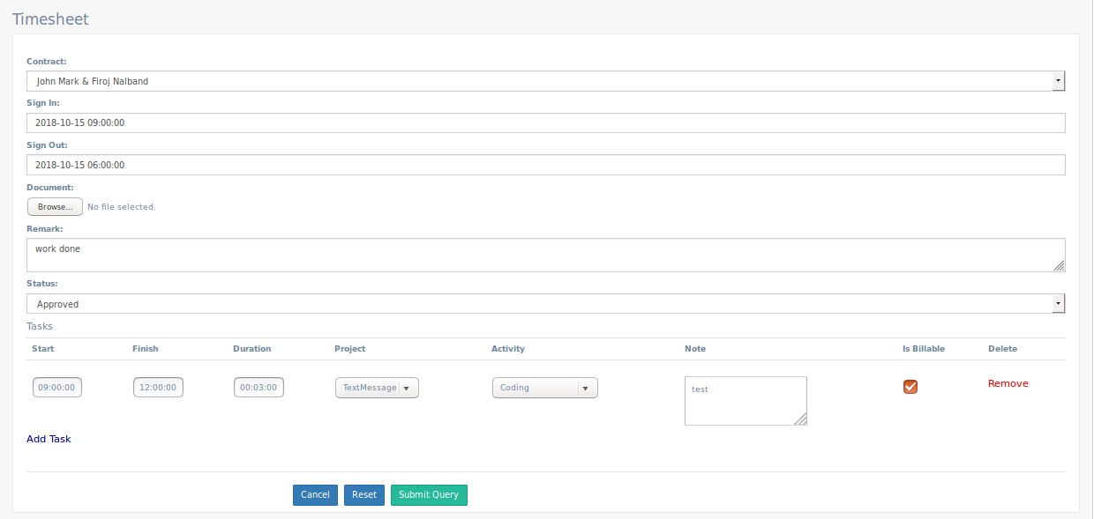

**What:**

This page will capture a timesheet.

**Who:**

Admin user of Triveni will use this page.

**When:**

4 days.

**Description:**

In Timesheet Management System, follow below steps-

* Login into admin account.
* Go to ‘Tracker’ menu and then select submenu ‘Timesheets’.
* Admin will get a list of timesheets.
* Admin can perform add/edit/delete operation by clicking on create/edit/delete button respectively.

**Use Case:**

* Add new timesheet-
* User save a timesheet related information like contract, sign_in, sign_out, tasks, is_billable, remark and status. Admin can also upload any document or image related this timesheet.
* Admin User can perform one of the following action on this page-
  + ‘Cancel’ button should redirect user to list page.
  + ‘Submit Query’ should save details on the form.
  + ‘Reset’ should reset data in the form.
* Edit existing timesheet-
* Initially, user should get all saved information of this timesheet in the form.
* User should update and save a contract information like contract, sign_in, sign_out, tasks, is_billable, remark and status. Admin can also upload any new document or image related this timesheet.
* Admin User can perform one of the following action on this page-
  + ‘Cancel’ button should redirect user to list page.
  + ‘Submit Query’ should save details on the form.
  + ‘Reset’ should reset data in the form.
* Delete existing timesheet-
* User should get confirmation message and do one of the following action on this page-
  + ‘Cancel’ button should redirect user to list page.
  + ‘Submit’ should delete this timesheet.

**Inputs/Defaults:**

Add or Update data in the form of a timesheet entity.

**Outputs:**

Added new timesheet or Updated existing timesheet information or delete timesheet.

**9. Assignment-**

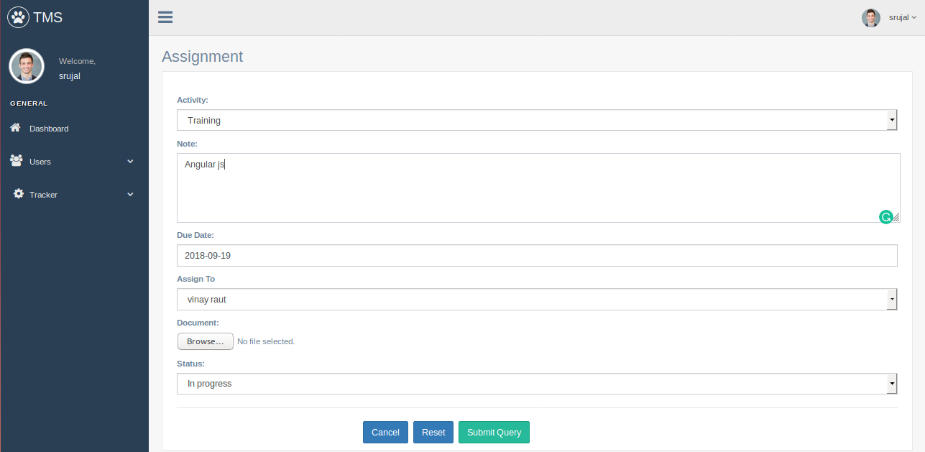

**What:**

This page will capture other tasks.

**Who:**

Admin user of Triveni will use this page.

**When:**

3 days.

**Description:**

In Timesheet Management System, follow below steps-

* Login into admin account.
* Go to ‘Tracker’ menu and then select submenu ‘Assignments’.
* Admin will get a list of assignments.
* Admin can perform add/edit/delete operation by clicking on create/edit/delete button respectively.

**Use Case:**

* Add new task-
* User save a task related information like activity, note, due date, employee and status. Admin can also upload any document or image related this task.
* Admin User can perform one of the following action on this page-
  + ‘Cancel’ button should redirect user to list page.
  + ‘Submit Query’ should save details on the form.
  + ‘Reset’ should reset data in the form.
* Edit existing task-
* Initially, user should get all saved information of this task in the form.
* User should update and save a task information like activity, note, due date, employee and status. Admin can also upload any new document or image related this task.
* Admin User can perform one of the following action on this page-
  + ‘Cancel’ button should redirect user to list page.
  + ‘Submit Query’ should save details on the form.
  + ‘Reset’ should reset data in the form.
* Delete existing task-
* User should get confirmation message and do one of the following action on this page-
  + ‘Cancel’ button should redirect user to list page.
  + ‘Submit’ should delete this task.

**Inputs/Defaults:**

Add or Update data in the form of a task entity.

**Outputs:**

Added new task or Updated existing task information or delete task.

**10. Change Password-**

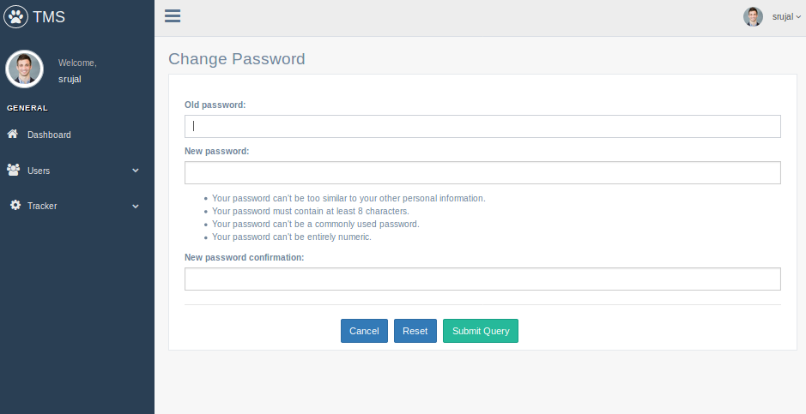

**What:**

This page will change password of logged-in user.

**Who:**

All users.

**When:**

0.5 day.

**Description:**

In Timesheet Management System, follow below steps-

* Login into account.
* Go to menus at top-right corner and then select submenu ‘Change Password’.

**Use Case:**

* Change password-
* User save new password.

**Inputs/Defaults:**

Add new password.

**Outputs:**

Password Changed.

**11. Selection of tenant-**

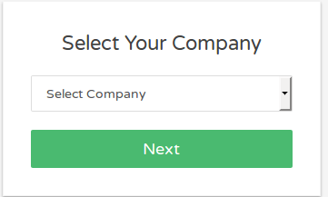

**What:**

This page to select a particular company or tenant.

**Who:**

All users.

**When:**

4 days.

**Description:**

* First page of a system.

**Use Case:**

* Select any one company or tenant from dropdown.
* Login page will display for selected tenant.

**Inputs/Defaults:**

Any one company or tenant.

**Outputs:**

User can access a particaular schema for a selected company or tenant from DB.

**12. Login-**

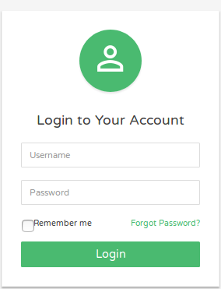

**What:**

Login Page.

**Who:**

All users.

**When:**

0.5 day.

**Description:**

In Timesheet Management System, follow below steps-

* First select any one tenant or company.
* Login to the system.

**Use Case:**

* Enter username and password. User should logged-in if user is successfully authenticated, else get error message.

**Inputs/Defaults:**

Username and Password.

**Outputs:**

Logged-in to the system.

**13. Forgot password-**

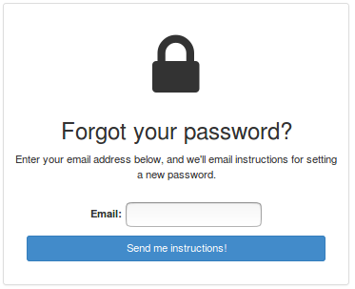

**What:**

Forgot Password Page.

**Who:**

All users.

**When:**

0.5 day.

**Description:**

* Click on ‘Forgot Password’ link on login page.

**Use Case:**

* Enter email.
* If user exist in the system with this email, then user should get URL with instructions on this mail.
* Use this URL and reset password of an account.

**Inputs/Defaults:**

Password.

**Outputs:**

Reset password of an account.

**14. Search Report-**

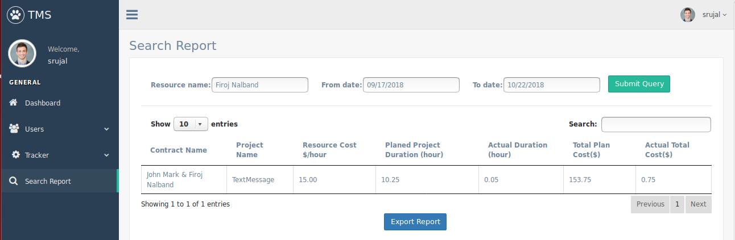

**What:**

Search Report Page.

**Who:**

All admin or managers.

**When:**

2 day.

**Description:**

* Logedded-in page.
* Select 'search menu' option from menu.

**Use Case:**

* Login.
* Select 'Search Menu'.
* Select date duration to generate report.

**Inputs/Defaults:**

Date duration(start and end date).

**Outputs:**

Report of resource.

**15. Dashboard-**

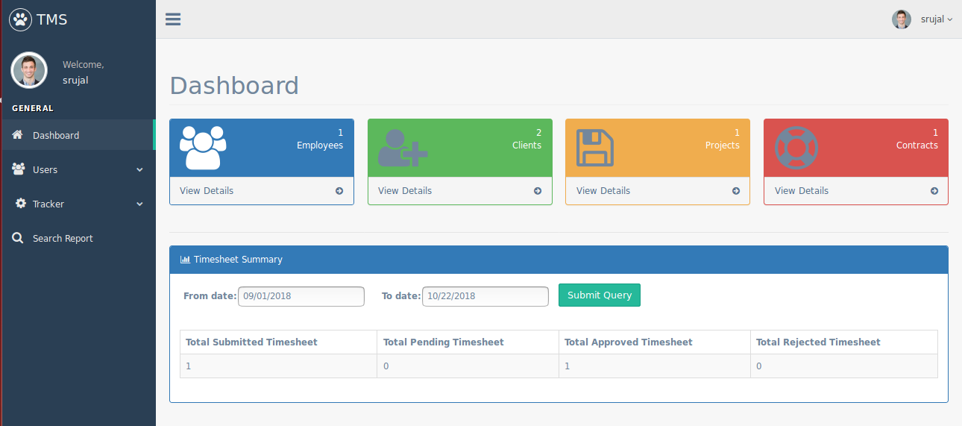

**What:**

All.

**Who:**

All users.

**When:**

1 day.

**Description:**

* Logedded-in page.
* Select 'Dashboard' option from menu.

**Use Case:**

* Login.
* Select 'Dashboard'.

**Inputs/Defaults:**

Date duration(start and end date).

**Outputs:**

Timesheet summary and entities count.

**16. Expense management of an employee-**

**fig.** List all expenses of an employee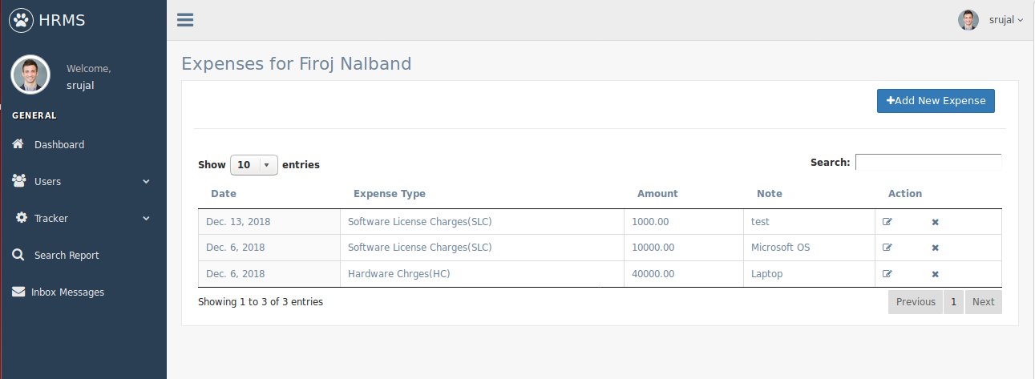

**fig.** Form to add or edit expense of an employee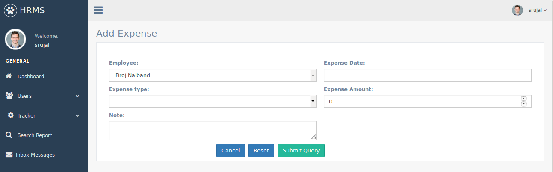

**What:**

To manage all expenses of an employee

**Who:**

Admin user of Triveni will use this page.

**When:**

1 day.

**Description:**

* Logedded-in page.
* Select 'Employees' option from 'Users' menu.
* Click on calculator icon of any one employee.

**Use Case:**

* User should display all list of an expenses of that employee.
* User should perform add/edit/delete operations on those expenses.

**Inputs/Defaults:**

Expense date, Type of Expense, Amount and Note/Description.

**Outputs:**

Add/Edit/Delete a record of an expense for selected employee.

**17. Invoice**

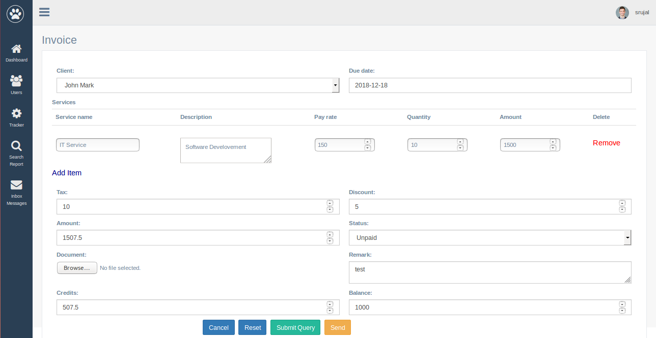

**What:**

Invoice for a client.

**Who:**

Admin user of Triveni will use this page.

**When:**

4 days.

**Description:**

* First Log-in to the system.
* Select 'Invoices' option from 'Tracker' menu.

**Use Case:**

* User should perform add/edit/delete/send operations on invoice.

**Inputs/Defaults:**

Client, Due date, Services, Amount, TAX, Discount, Document, Credits, Balance, Status and Remark.

**Outputs:**

Add/Edit/Delete/Send an invoice.